SET 1
Name: MALOTH ADITYA
Roll No.: 120CS0124

1.
a. DNS query is sent to 18.72.0.3.
The ip address cannot be the local DNS server.
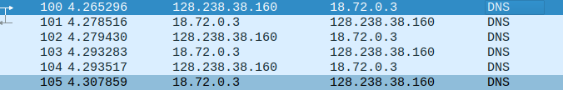

b. The DNS message type is Standard query.
The query message does not contain any answers
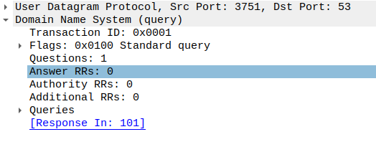
c. The DNS response provides following nameservers:
W20NS.MIT.EDU
BITSY.MIT.EDU
STRAWB.MIT.EDU
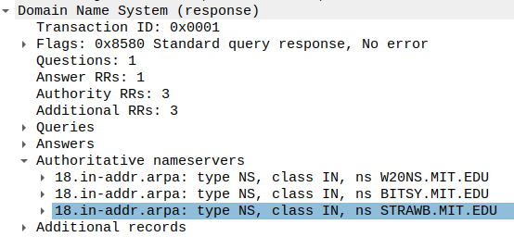
d. Yes, the response message provides ip addresses of the nameservers
W20NS.MIT.EDU 18.70.0.160
BITSY.MIT.EDU 18.72.0.3
STRAWB.MIT.EDU 18.71.0.151
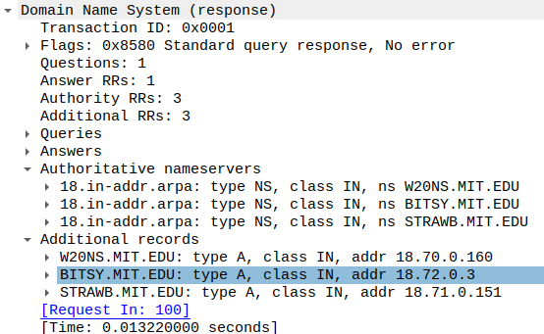

2.
TCP SERVER:
//TCP Server program
#include <sys/types.h>
#include <sys/socket.h>
#include <netinet/in.h>
#include <arpa/inet.h>
#include <stdio.h>
#include <unistd.h>
#include <stdlib.h>

int main(){
int serid,sessid,num1,num2;
struct sockaddr_in server_address,client_address;

unsigned int server_addlen,client_addlen;

server_address.sin_family=AF_INET;
server_address.sin_addr.s_addr=inet_addr("127.0.0.1");
server_address.sin_port=9876;

server_addlen=sizeof(server_address);
client_addlen=sizeof(client_addlen);

serid=socket(AF_INET,SOCK_STREAM,0);

bind(serid,(struct sockaddr*)&server_address,server_addlen);

listen(serid,10);

while(1){
printf("Server is ready to accept ......\n");
sessid=accept(serid,(struct sockaddr *)&client_address,&client_addlen);
read(sessid,&num1,4);
read(sessid,&num2,4);
printf("\nMessage received from client\nThe numbers are: %d %d\n\n",num1,num2);
num1 = num1/num2;
write(sessid,&num1,4);
close(sessid);
}
return(0);
}

TCP CLIENT:
//TCP Client program
#include <sys/types.h>
#include <sys/socket.h>
#include <netinet/in.h>
#include <arpa/inet.h>
#include <stdio.h>
#include <unistd.h>
#include <stdlib.h>
#include <string.h>

int main(){
int sid,num1,num2;
struct sockaddr_in server_address;
int server_addlen;

server_address.sin_family=AF_INET;
char ipAddr[15];
printf("Enter the server IP address: ");
gets(ipAddr);

server_address.sin_addr.s_addr=inet_addr(ipAddr);

server_address.sin_port=9876;

server_addlen=sizeof(server_address);

sid=socket(AF_INET,SOCK_STREAM,0);

connect(sid,(struct sockaddr *)&server_address,server_addlen);
printf("Connected Successfully\nEnter two numbers: ");
scanf("%d %d",&num1,&num2);
write(sid,&num1,4);
write(sid,&num2,4);
read(sid,&num1,1);

printf("\nMessage received from server\nAns: %d\n",num1);
close(sid);
return(0);
}

OUTPUT:

CLIENT:
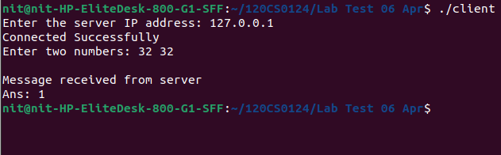
SERVER:
